History :

|  |  |
| --- | --- |
| Objective | Data |
| Personal Data | * Name * Age * Menstural Cycle * Marital status * Number of children * Residency * Occupation * Special habits * Chronic diseases. |
| Chief complaint | * Breast lump. * Pain(Mastalagia). |
| Present History | * Analysis of complaint * Associated symptoms |
| Past History | * Radiation exposure * Previous investigations (mammograms, imaging, FNAC study). * Previous Clinic visits * Chronic diseases * Hospital admissions * Previous Surgeries and complications. |
| Familial History | Familial predisposition of :   * Breast carcinoma. * Ovarian carcinoma.   And the age of those affected. |
| Drug History | * Prescribed drugs * OTC * Topical drugs * Hormonal therapies (known to rise estrogen levels). |
| Other Systems Complaints | * Systems review |

Chief Complaint :

--> Breast lump.

--> Mastalgia.

--> Tenderness.

--> Skin and nipple changes.

Breast Lump (most common disorder) :

--> Onset (When it first appears ?).

--> Number (How many lumps out there ?).

--> Size (How big ?).

--> Location (Where ?).

--> Consistency (Soft, firm or hard).

--> Course (increasing in size ?).

--> Tenderness (is it sore to touch ?).

--> Relation to surroundings (mobile or fixed to the surroundings).

--> Menstural cycle relations (size increasing w/ menses ?).

--> Associated Symptoms (pain/skin-nipple changes ?).

Mastalgia :

--> Should be distinguished from chest wall pain.

--> Menstural Cycle relations :

|  |  |
| --- | --- |
| Pain type | Menstural Relations |
| Cyclical | Worse in the latter half of the cycle and relieved by the end of mensturation. |
| Non-cyclical | No changes with the menstural cycle. |

Skin Changes (reported or noted during examintaion) :

--> **Simple Skin dimpling** : the skin is still mobile above the cancerous tissue.

--> **Indrawing of the skin** : the skin is attached to the underlying cancerous tissue and fixed in place.

--> **Lymphedema** : embedded lymphatics edema leads to swollen skin which appears in the form of circular ridges around hair follicles (Peau d’orange -- Orange Peel appearance).

--> **Eczema of nipple and areola** : Paget’s disease or intraductal carcinoma.

Nipple changes :

--> Nipple inversion (retraction) : asymmetrical/symmetrical -common-often benign-can be first sign of malignancy (asymmetrical).

--> Nipple discharge : clear - yellow - green - bloody - onset - course - duration - associated symptoms (pain/skin changes).  
--> Galactorrhea : milky discharge - most commonly caused by drugs and after breast feeding - rarely due to hyperprolactinemia.

Gynaecomastia :

--> Often occurs in pubertal boys.

--> Drug induced (Cimetidine --> hyperprolactinemia).

--> Chronic liver diseases (due to liver not metabolizing estrogen).

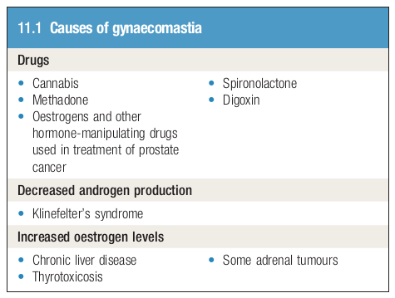

Examination :

1. Always offer a chaperone (nurse) and record her name.
2. General Examination :   
    - Vital Signs (general appearance, BP, HR, RR).

- Conscious level.

## Ask the patient to undress to the waist and sit upright on a well-illuminated chair or on the side of a bed -- leaving her with the chaperone until undressing is successful and make sure she is covered with something until the start of examination ##

3) **Local Examination :**

|  |
| --- |
| **Positions of the patient** |
|  |
| **Areas to inspect, palpate and comment on** |
|  |

--Inspect while the patient is sitting--

1. Relax pectoral muscles (by asking the patient to rest her hands on her thighs) - fig-(A).
2. Look for :

- Breast Asymmetry.

- Any Masses.

- Skin lesions.

- Ulceration.

- Skin/Nipple changes (discharge/ulceration/retractions/skin dimpling/scars).

1. Comment out your findings.

Eg : On inspection, the two breasts aren’t symmetrical, there’s a breast mass at the upper right outer quadrant at 10’clock, there is nipple inversion on the left breast.

1. Contract pectoral muscles (by asking the patient to press her hands firmly on her hips) and inspect again adding any new changes and if the previously inspected mass moves with muscle contractions or it’s free. fig-(B)
2. Comment your findings.
3. Exacerbate skin dimpling technique (by asking the patient to place her hands behind her head and lean forward), inspect and comment out your findings. Fig-(C)

--Palpate while the patient is lying down--

|  |
| --- |
| Position for examination (starting from the healthy breast) |
|  |
| Examination technique |
|  |

|  |  |
| --- | --- |
| Palpate the nipple | Test for any nipple discharge |
|  |  |

* Palpate circularly in a clockwise manner starting from the outside and moving inwards.
* Palpate the nipple and areola for any changes and discharge.
* Elevate the breast with your hands and inspect for any skin dimpling (suggests an underlying tumor).
* Examine the axillary tail (by holding it between fingers).
* If you have found a mass, comment it out :   
  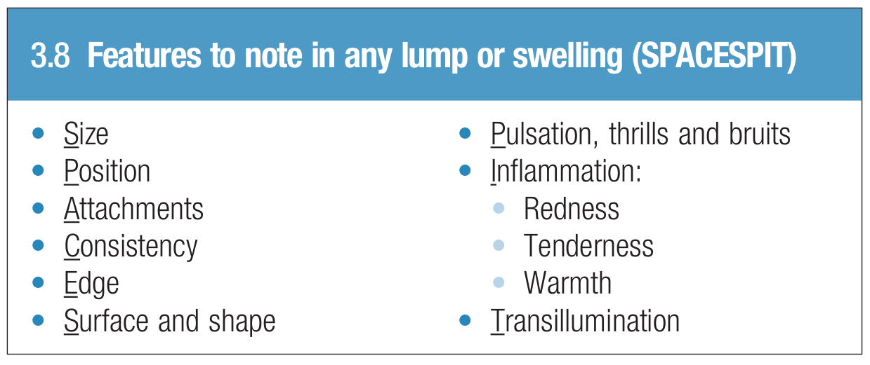
* Check if the mass is fixed :
  + - To the underlying skin -- by grasping a skin fold abve the mass and moving it around.
    - To the underlying muscles and fascia -- by asking the patient to tense her hands on her hips (contract the pectorals) while holding the mass.

--Palpate regional lymph nodes--

|  |  |
| --- | --- |
| Direction of flow | Groups |
|  | Within the Axilla :   * Lateral Group * Central/Deep Group * Anterior Group (Pectoral) * Posterior Group (Subscapular).   Within the clavicular region :   * Supraclavicular Group. * Infraclavicular group.   Within the Head and neck.  NB : not all the lymphatics of the breast drain into the axilla. Malignant cells from a breast cancer may spread directly to the infraclavicular nodes or into the internal mammary chain of lymph nodes within the chest. |

--Percussion--

- On the vertebra : for vertebral column metastasis via the azygos~external vertebral plexus route.

- On the lung.

--Check for SMJN (Sister Mary Joseph Nodule, but beware it’s not specific to the breast carcinoma--

Last to know

Investigations for breast lumps :

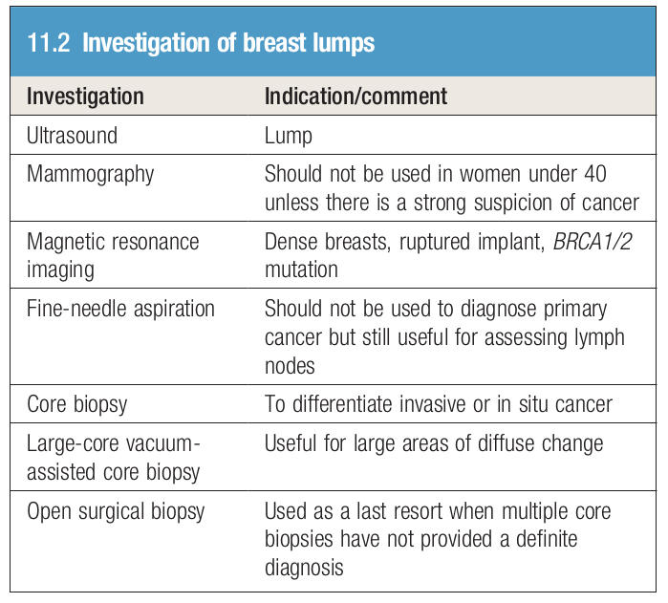

Risk factors for developing breast cancer

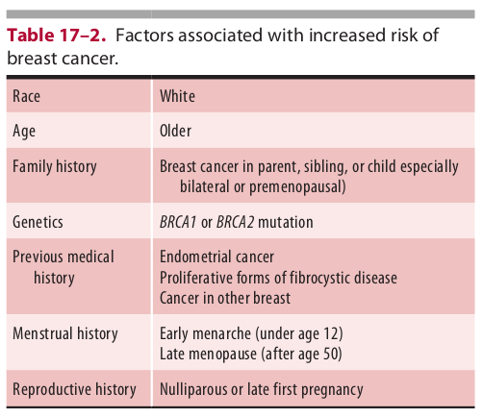

Evaluation of breast lump :  
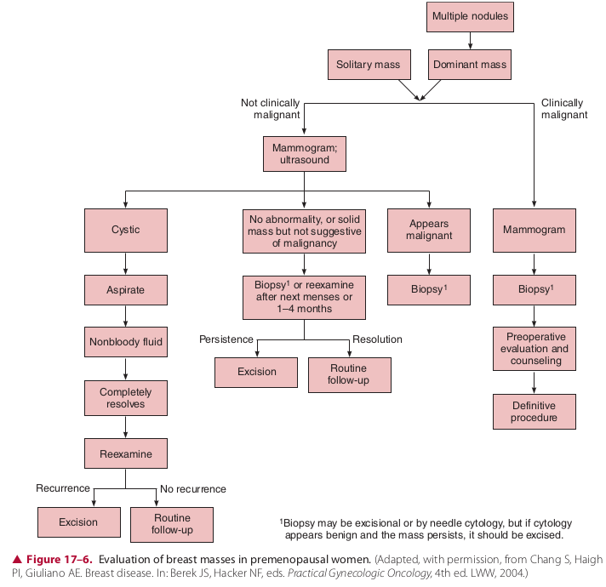

# Last Record your findings :

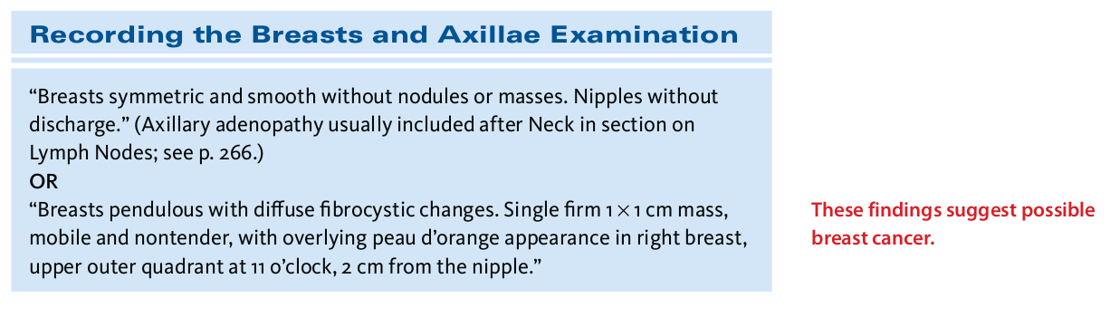

Thumbnails

Anatomy :   
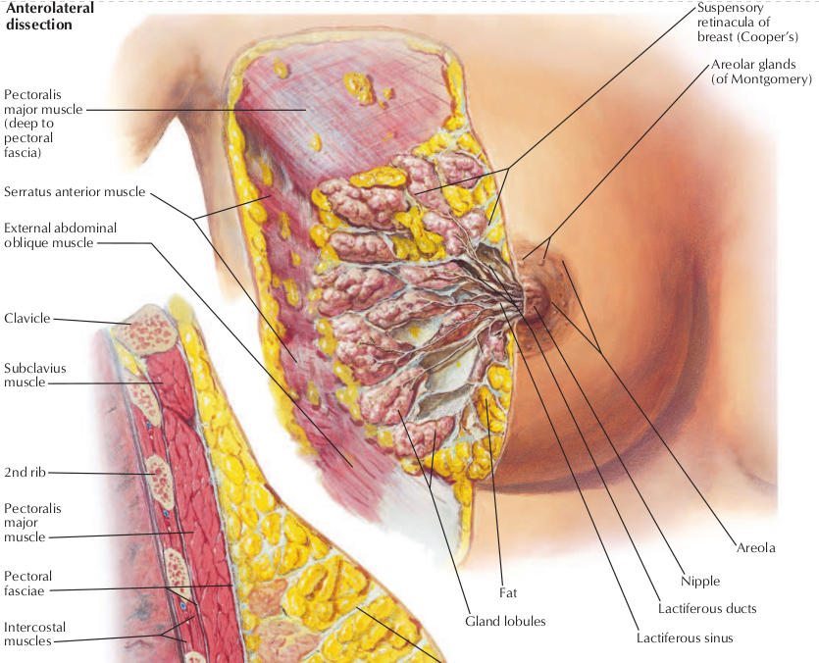

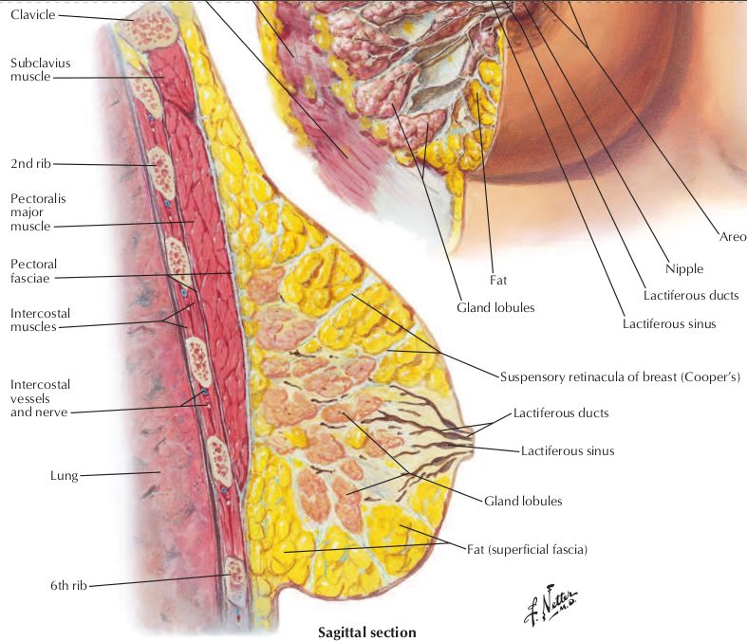

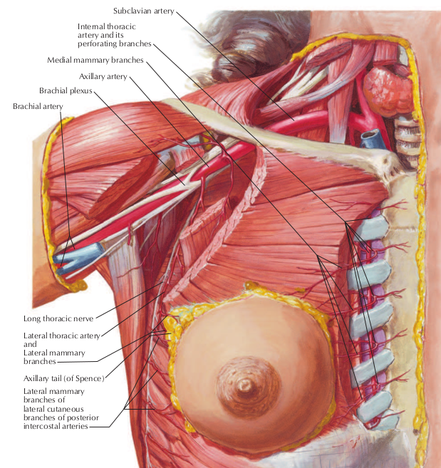

- Breast is suspended by the suspensory retincula of breast (Cooper’s Ligaments).

- Cooper’s ligaments arise from the pectoral fascia.

- Breast = 15 - 20 lobes

- 1 lobe has 1 major lactiferous duct.

- 1 lobe = 20 - 40 lobules

- 1 lobule = several Alveoli + ductule.

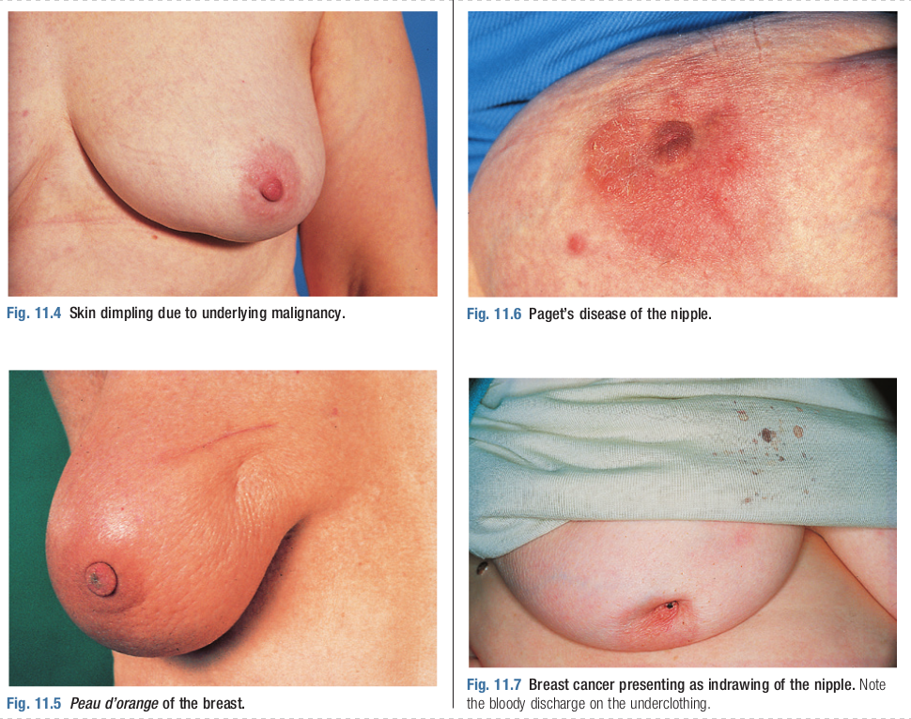

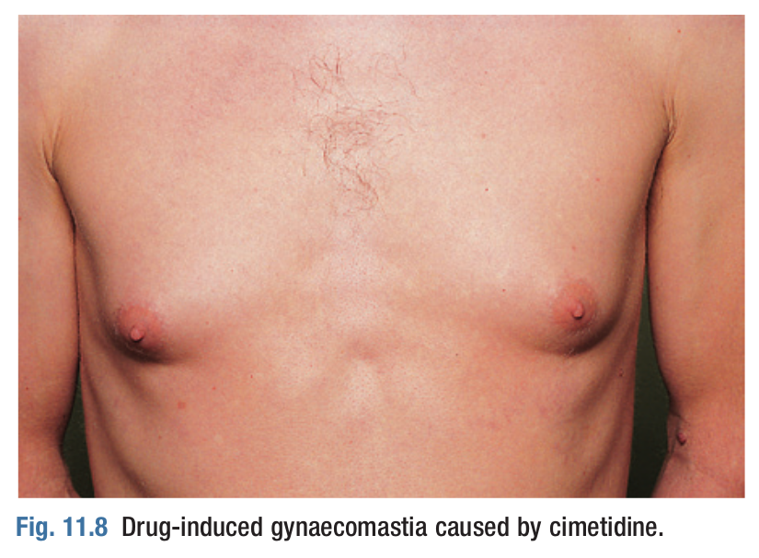

# Resources :   
1) Macleod’s Clinical examination.

2) Bate’s Guide to physical examination.

3) Netter’s Atlas of human anatomy.

4) Current Surgery 14th edition.